*“As the father of a son with autism, I understand the hardships millions of other American families face everyday. Children with disabilities need a wide range of medical and long-term services and support that our current healthcare system does not prioritize. or they are only available in limited amounts through private insurance.”*

*-Andrew Yang*

***Have you or a loved one gone through the ordeal of trying to get SSI for a disability? Then you know what a bureaucratic nightmare it is.***

***The average wait time in getting SSI approval for being disabled is 4 months, and an appeal takes an average of 15 months! When the average American cannot afford an emergency $400 expense, we believe that's at least 4 months too long!***

***And then even with a successful application you still have to face demeaning and arduous "reevaluation" processes every couple years -even if you have an obvious permanent disability.***

***With denials and appeals these stressful and demeaning reevaluations can take years, costing thousands in bureaucratic overhead!***

**If this leaves you thinking there's got to be a better way, there is:**

**It's not Left. It's not Right. It's Forward!**

**Yang's Freedom Dividend would give every American, regardless of medical or financial condition, $1000/mo. to anyone who opts-in.**

**No check-ups. No appeals. No bureaucracy.**

**No Contest.**

**Yang2020.com**

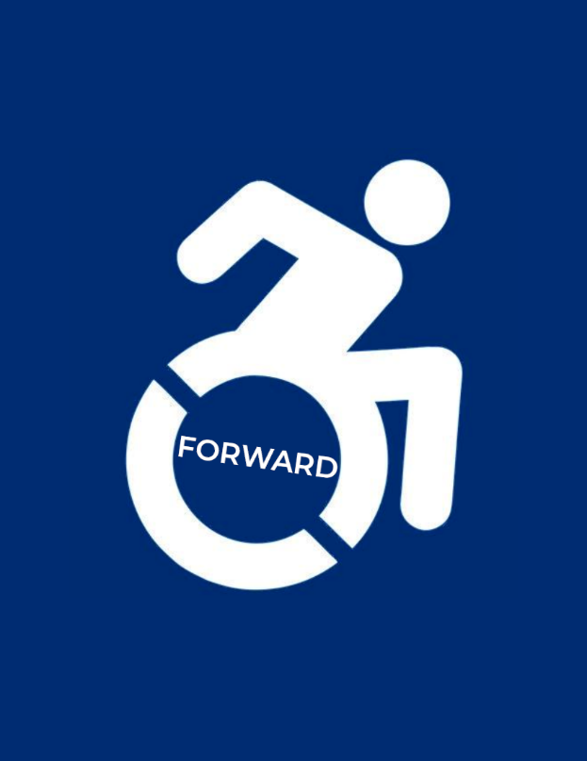

See Policy: Care for People with Disabilities

How UBI improves our social safety net

______

_______

_____